**BALLYORAN**

**PRIMARY SCHOOL**

*Principal* | *Mr R Woolsey, BEd (Hons), PQH*

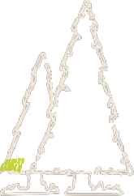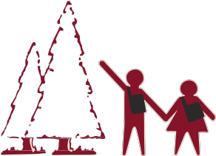

11th January 2024

Dear Parent/Guardian

**Full Day School Closure – Thursday 18th January 2024**

All Teaching and Non-Teaching Unions in Northern Ireland are currently in a pay dispute with the Employers which has resulted in Teachers and Non-Teaching staff taking part in Industrial Action.

The unions have instructed their members to engage in a Full Day Strike on **Thursday 18th January 2024.**

This means that Ballyoran Primary School will be closed on this date.

Yours Faithfully

Richard Woolsey

Principal

**Ballyoran Primary School,** *Ballyoran Park, Portadown, Craigavon, Co Armagh, BT62 1JY*

*T: 0283835 2009 F: 028 3836 1818 E:* [*info@ballyoran.portadown.ni.sch.uk*](mailto:info@ballyoran.portadown.ni.sch.uk) [*www.ballyoranps.com*](http://www.ballyoranps.com/)